APC Rack SNMP + USB Monitoring Installation & Configuration Manual
  - For Network Engineers: SMX3000LVNC (Primary) and BVN650M1 (Secondary) via VLAN 99

Technical Overview
- Objective: Enable SNMP monitoring on the primary UPS (SMX3000LVNC) and USB monitoring on the secondary UPS (BVN650M1) using VLAN 99 management network.
- Estimated Time: 1.5–2.5 hours plus a 15-minute buffer for edge cases (e.g., firmware quirks).
- Risks: SNMP string exposure (mitigated via VLAN 99 firewall and enforcing read-only access); halt procedure if Network Management Card (NMC) is absent.
- Change Log Highlights:
- Updated OIDs to PowerNet-MIB v4.2.1.
- Primary model: SMX3000LVNC (3000VA/2700W).
- Script uses AND-logic, stateful and robust parsing.
- BVN USB monitoring via binary/Podman container.

Rack Baseline
UPS | Model | VA/Watt | Battery Health | Runtime | Interface
Primary | SMX3000LVNC | 3000VA/2700W | 92% | ~16 min @1350W (half-load) | SNMP (NMC)
Secondary | BVN650M1 | 650VA/360W | N/A | ~10–15 min @180W | USB (apcupsd)
Note: SMX runtime assumes 92% battery health (degraded from 18 min spec). Verify via NMC self-test (Menu → Test → Runtime Calibration).

Technical Specifications & Prerequisites

SNMP Requirements (Primary SMX3000LVNC)
- Version: SNMPv2c (read-only; enforced by access type).
- Key OIDs (PowerNet-MIB v4.2.1):
- Battery Capacity (%): .1.3.6.1.4.1.318.1.1.1.2.2.1.0
- Output Load (%): .1.3.6.1.4.1.318.1.1.1.4.2.3.0
- Runtime Remaining (min): .1.3.6.1.4.1.318.1.1.1.2.2.3.0 (timeticks/6000)
- Battery Status: .1.3.6.1.4.1.318.1.1.1.2.1.1.0
- Traps: On-battery, low-battery (<20%), replace-battery
Bandwidth: <1 Kbps for polling; <10 Kbps for traps

USB Monitoring (Secondary BVN650M1)
- Interface: USB (monitored via apcupsd on UDM; SNMP not supported)
- Key Metrics: Battery %, load, runtime (polled via software)
- Alerts: Low battery (<20%), runtime <5 min

Network & Hardware Settings
- VLAN: 99 (Mgmt; SMX Static IP: 10.99.0.2/28 on port 48 GbE non-PoE; BVN USB direct to UDM)
- UDM Integration: SNMP for SMX; apcupsd for BVN
- Prerequisites:
- Access to SMX NMC UI (via DHCP or scan; admin/physical password required)
- apcupsd v3.14.14+ (manual binary or Podman container on UDM)
- Browser, wget/tar, Podman, USB cable (<15 ft for BVN)
- NMC Firmware: AOS 3.x+ for full SNMPv2c
Considerations: If UDM USB unreachable, fallback to BVN LCD; verify UDM USB compatibility with BVN pre-production (lsusb)

Installation & Configuration Procedure

Phase 1: Pre-Migration Preparation (45 min)
- UPS Inventory Audit
- Locate both UPS units in rack; note serial numbers and firmware (LCD: Menu > Status > About); verify model numbers.
- Verify NMC presence on SMX (check rear panel for Ethernet port and LEDs). If absent, halt and order AP9631 NMC.
- Record current IP address (likely DHCP); scan VLAN 99 or connect directly via laptop if needed.
- Document UPS details in a "UPS Hero Sheet" (Google Sheets) using the following template:
UPS IDModelS/NIP/InterfaceMAC/USBVLAN PortCommunity/StringNotes
PrimarySMX3000LVNCABC12310.99.0.200:11..99-48mgmt_ro_202592% batt; ~16 min @1350W
SecondaryBVN650M1DEF456USB to UDMN/AUDM USBapcupsdAux <300W; 10-15 min
- Physical Preparation
- Label cables: SMX Ethernet (blue: "SMX-Mgmt → USW-48"); BVN USB (red: "BVN-Aux → UDM-USB"). Photograph rack for documentation.
- Export SMX NMC configuration (UI: Config > Backup); snapshot BVN LCD.
- Staged Validation Plan
- Validate SMX NMC first, then BVN USB.
- Success criteria: SNMP polling/traps on SMX; USB metrics on BVN (<5s response).
- HALT if NMC is absent or access fails.

Phase 2: Primary UPS (SMX) SNMP Configuration (30 min)
- Access & Basic Network Setup
- Connect laptop to SMX NMC via Ethernet; identify IP via scan or LCD.
- Access NMC UI: [URL] IP]; login with admin credentials.
- Set static IP (10.99.0.2/28), gateway (10.99.0.1); apply changes and verify connectivity (ping UDM).
- Enable SNMPv2c
- Navigate: Config > Network > SNMPv1/v2c; enable SNMP v1/v2c.
- Set community string ("mgmt_ro_2025"); enforce read-only access.
- Add trap receiver (10.99.0.1:161); enable on-battery, low-battery, and replace-battery traps.
- Apply and reboot NMC.
- Verification
- Run: snmpget -v2c -c mgmt_ro_2025 10.99.0.2 .1.3.6.1.4.1.318.1.1.1.2.2.1.0
- Expected output: SNMPv2-SMI::enterprises.318.1.1.1.2.2.1.0 = INTEGER: 92 (battery %)
- If error: Check firewall/ping or verify OID/MIB version.

Phase 2B: Secondary UPS (BVN) USB Monitoring (15 min)

Step 2B.1: UDM Setup (USB Direct, Manual Binary)
- Verify UDM USB compatibility (SSH: lsusb, expect "American Power Conversion").
- Install apcupsd (choose one method)
- Pre-compiled Binary (Recommended):
- Download and extract: wget [URL], tar -xzf apcupsd-3.14.14-arm64.tar.gz
- Copy binaries and config: cp apcupsd-3.14.14/sbin/apcupsd /usr/sbin/, cp apcupsd-3.14.14/etc/apcupsd/apcupsd.conf /etc/apcupsd/
- Set executable: chmod +x /usr/sbin/apcupsd
B. Podman Container (Stable):
Run container: podman run -d --name apcupsd --device=/dev/usb/hiddev0 -v /etc/apcupsd:/etc/apcupsd gersilex/apcupsd:latest
Enable restart on boot: podman generate systemd --new --name apcupsd > /etc/systemd/system/apcupsd.service; systemctl enable apcupsd.service
Alternatively, add to /config/scripts/post-boot.sh: podman start apcupsd
C. External Host (Fallback): Use Raspberry Pi on VLAN 99 (10.99.0.3); script via SSH poll.
Connect BVN USB and confirm detection.
Enable Monitoring
Edit /etc/apcupsd/apcupsd.conf: UPSTYPE usb; DEVICE; ONBATTERYDELAY 6; BATTERYLEVEL 20; KILLDELAY 120 (default values otherwise).
Restart apcupsd: systemctl restart apcupsd (binary) or podman restart (container).
Check status: apcaccess status (shows batt/load/runtime).
Configure UDM notifications (e.g., email on battery capacity <20%).
Verification
Run apcaccess: Expect runtime ~10–15 min @180W.
If USB reach fails, fallback to BVN LCD (Menu > Status).

Phase 3: UniFi UDM Integration (15 min)
- Enable SNMP on UDM (for SMX)
- Console: Settings > CyberSecure > Traffic Logging > SNMP: Enable v2c; set community "mgmt_ro_2025".
- Note: This enables UDM to respond to SNMP polls and to poll SMX using the configured community string.
- Add Devices & Unified Alerts
- Add SMX device: Devices > SNMP Add: 10.99.0.2.
- Configure alerts:
- Low Battery: OID .1.3.6.1.4.1.318.1.1.1.2.2.1.0 <20%
- Critical Runtime: OID .1.3.6.1.4.1.318.1.1.1.2.2.3.0 <5 min (post-conversion)
- Extend alerts to BVN via apcupsd integration.
- Implement tandem monitoring script (polls every 5 min):
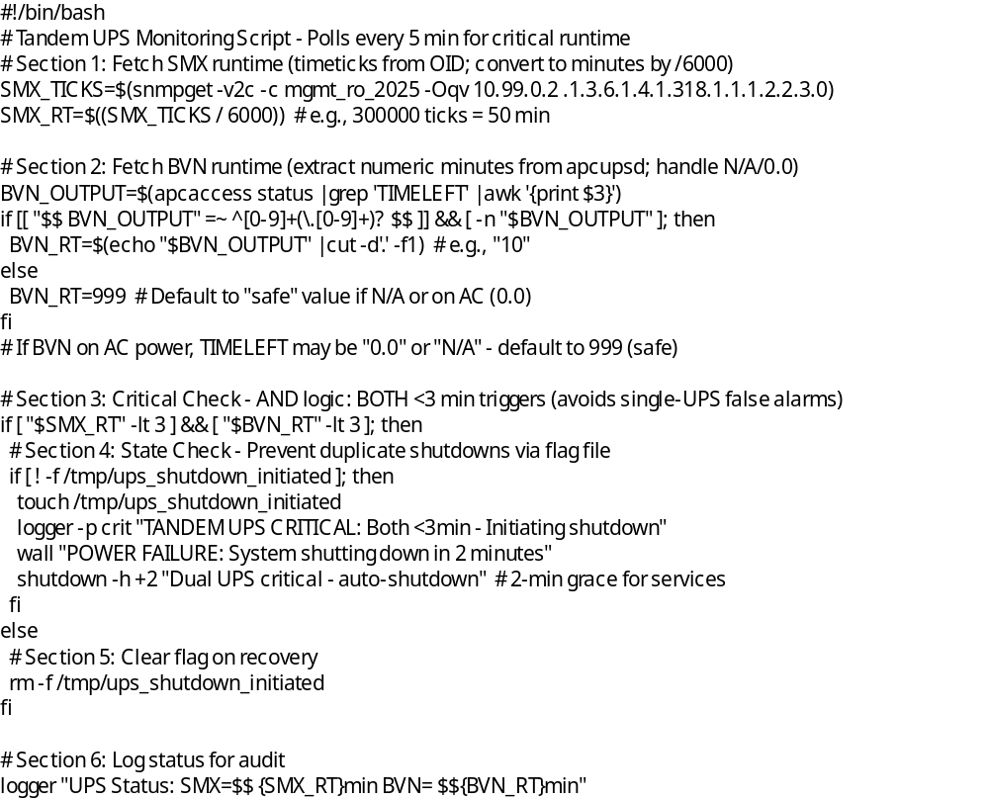
- Save script, set executable, and add to crontab or post-boot scripts as appropriate.
- AND logic ensures both UPS units are critical before shutdown.

Phase 4: Execution & Testing (30–60 min, Off-Hours)
- Staged Enablement
- Connect SMX to port 48; adopt and test SNMP polling/traps (LCD self-test).
- Connect BVN USB to UDM; verify apcaccess; simulate low-battery (partial discharge, safe).
- Full Validation
- Simulate tandem outage by unplugging AC; monitor runtimes and alerts.
- Trap Validation
- Monitor UDM logs: tail -f /var/log/messages | grep TRAP
- SMX LCD: Menu → Test → Simulate Power Failure (10 sec); verify trap received within 5 sec.
- Cancel test via LCD to restore.
- Baseline with Wireshark on VLAN 99 for SNMP traffic (filter: ip.src==10.99.0.2).
- Rollback (If Needed)
- Revert IPs and disconnect hardware if necessary.
- Restore NMC backup; stop apcupsd; document configuration changes.

Testing & Validation Checklist
- SMX SNMP: OID poll <5s; traps appear in Insights.
- BVN USB: apcaccess reports runtime ~10–15 min; alerts trigger.
- Tandem Script: Triggers warning if both runtimes <3 min; logs status variations.
- VLAN 99: SMX is pingable; BVN detected via USB.
- Runtime: SMX ~16 min @1350W; BVN ~10–15 min @180W.
- Alerts: <20% battery triggers consolidated notifications.

Troubleshooting
- SMX NMC Fail: Scan IP (DHCP?); reset; collect S/N, firmware, event log, network backup before escalation; verify with ping/snmpwalk.
- BVN USB Silent: Check with lsusb; adjust configuration; fallback to LCD if unreachable.
- OID Errors: Confirm MIB version; use snmpwalk; escalate to Ubiquiti if UDM poll fails.
- Script Glitch: Check logs (/var/log/apcupsd, syslog); verify timeticks; escalate cron issues to UDM forum.
- No NMC: Order AP9631; use LCD interim; escalate procurement if needed.

Known Limitations
- BVN lacks SNMP: USB polling ~10s latency vs. SMX real-time; LCD fallback available.
- SNMPv2c Security: Enforced RO via access type; VLAN 99 blocks external access—use ACLs for scaling.
- Script Polling: 5-min interval; suitable for rack-level monitoring.

Post-Migration Optimization (Week 1)
- Consolidate alerts on UDM dashboard; test notification chain (email/Slack).
- Quarterly battery self-tests (LCD); replace if <80% health (SMX RBC132, BVN APCRBC124).
- Security: Rotate SNMP community strings annually; audit VLAN ACLs.
- Expansion: Port 46 available; consider SNMP-enabled PDUs if rack grows.

